Almost, But not quite, Entirely unlike tea

I am a teapot.
Difficulty: Hard
Ben Poulton
Securi-Tay CTF 26

Solution
The provided APK is an app that opens a web view to example.com. This is a hint as to what the app should be doing. If the apk is decompiled using JADX or a similar tool, the strings.xml file can be found and contains a COFEEPOT_URL string, which leads to a web server. However, when visiting this web server, the browser is served with a 418 error.
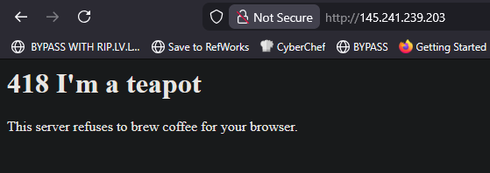
Further decompilation of the APK will reveal that the APK uses a specific browser agent when opening the webveiw. This user agent is “Automatic Coffee Dispenser 1.042”

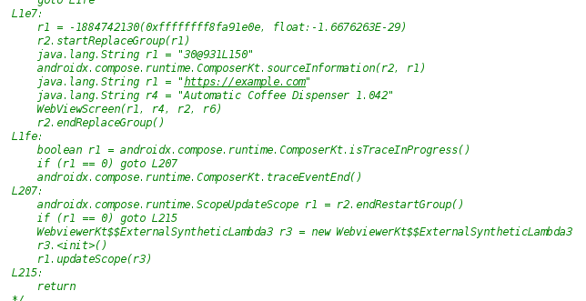
Accessing the site with this user agent provides the flag
SECURI-TAY{Br3w1ng_Us3r_Ag3nt5}

